Pekerjaan rumah
Minggu 2-3

Make your own town. Draw your town with at least 15-20 different public places. Then, write 10 sentences to tell about the position of the places.
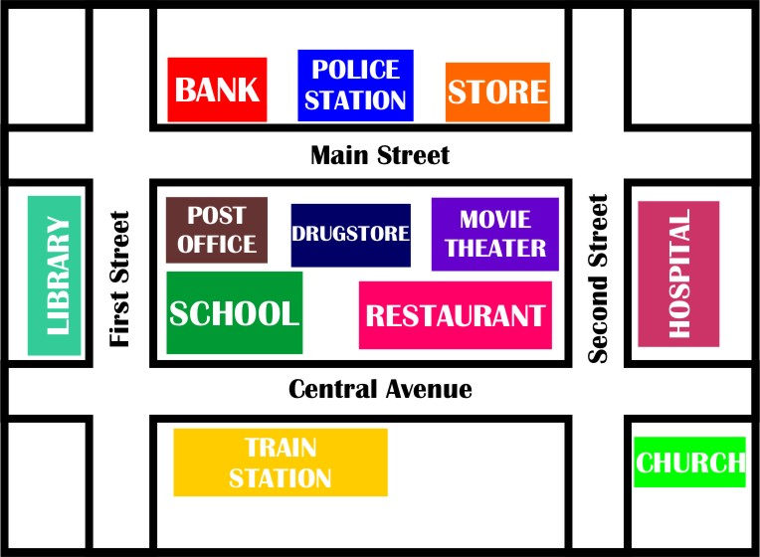
Example:
- Kantor polisi ada di depan apotek
- Bank ada di depan kantor pos.
- Bioskop ada di samping kiri apotek.

Notes: label the places in your map in Bahasa Indonesia.
Posisi : position
Di depan : in front of
Di belakang : behind
Dekat : close to
Jauh : far from
Di samping : next to
Di sebelah : next to
Kiri : left
Kanan :right

