Bahasa Indonesia homework for Year 5 (group : beginner)
week 3 term 2, 2016-2017

A. Deskripsikan gambar-gambar ini dalam 50 kata! Gunakan kata-kata di daftar kosa kata (Describe these pictures in at least 50 words! Use words in the word list!)
Example : Ada banyak bangunan besar di kota.

gambar 1 (picture 1)
______________________________________________________________________________________________________________________________________________________________________________________________________________________________________________________________________________________________________________________________________________________________________________________________________________________________________________________________________________________________________________________________________________________________________________________________________________________________________________________________________________________________________________________________

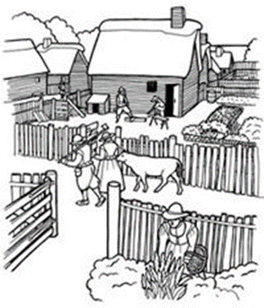

gambar 2 (picture 2)
________________________________________________________________________________________________________________________________________________________________________________________________________________________________________________________________________________________________________________________________________________________________________________________________________________________________________________________________________________________________________________________________________________________________________________________________________________________________________________
tata bahasa (grammar ): -the use of “ada” means “there is/are” and “tidak ada” means “there is not”
-the use of “banyak” (a lot) and “sedikit” (a few) indicating quantity of something.
-the use of “di” as preposition of place.
-Pattern : Ada banyak/sedikit … (things) di …(place).
Tidak ada … (things) di … (place).
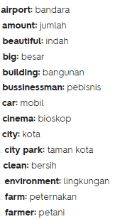
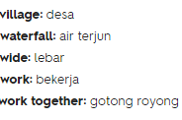
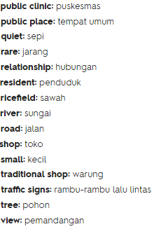
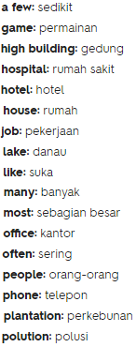
kosa kata:

