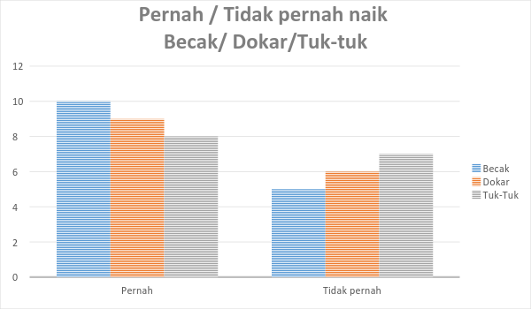
Read the chart below. It is about a survey in one class that consist of 15 students whether they have been on becak, dokar or tuk-tuk. . fill in the table underneath based on the chart.

 | Becak | Dokar | Tuk-tuk
Pernah | 10 orang
Tidak pernah

What can you conclude about the class experiences being on traditional vehicles, from the chart above?
…………………………………………………………………………………………………………………………………………………………………………………………………………………………………………………………………………………………………………………………………………………………………………………………………………………………………………………………………………………………………………………………………………………………………………………………………………………………………………………………………………
Practice the following expressions!

Mau kemana? - where are you going?
Naik apa kesana? - how do you go there?
Berapa lama? - how long?
Apa warna sepeda kamu? - what color is your bicycle?
Anda mau tiket apa? - what ticket do you want?
Ada yang bisa saya bantu? - Can I help you?
Selamat datang - welcome
Tiket anak-anak - kids ticket
Tiket dewasa - adult ticket
Jam berapa tutup? - what time is it closed?
Ada brosur? - is there any brochure?
Saya mau membeli tiket - I want to buy tickets.
Ada kamar kecil di dalam kebun binatang? - is there any toilet inside?
Saya mau tiket jurusan Jakarta – Semarang. - I want a ticket from Jakarta – Semarang.
Maaf, tiketnya sudah habis. - Sorry, the ticket is sold out.
Apa ada promo? - Is there any promo?

