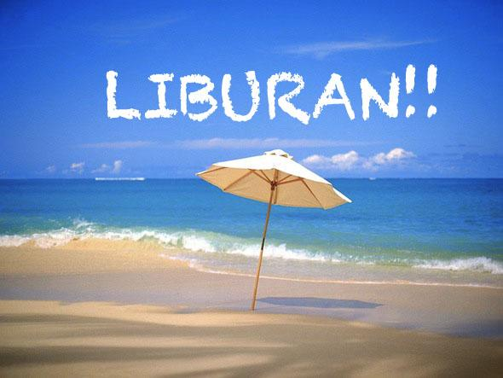
Design a poster of your holiday! Where did you go? With who? What did you do? How was it? Put some pictures about your holiday and write 1-2 sentences to tell about the pictures. Use the word list!
Verb (action words)
Mengunjungi – visit
Pergi – go
Datang – come
Jalan-jalan – travelling
Berbelanja – shopping
Tinggal di rumah – stay at home
Jalan-jalan- travelling
Berenang – swimming
Berselancar – surfing
Melihat-lihat – looking around
Makan di restoran – eating out
Bersantai – relaxing
Memancing – fishing
Menonton film – watching movies
Memasak – cooking

With – dengan
Ke – to
Dari – from
Untuk – for
Ketika – when

Keren – cool
Asyik – fun
Membosankan - boring

Bermain papan roda- skate board
Sepatu roda: roller skate
Papan seluncur : snowboard
Membeli – buy

