Year 5 Home Learning Grid
TERM 1, WEEK 7
Due Friday, September 23th
MATH |  | SPELLING |  | READING/UOI
Complete questions on Prodigy each night.  If you have difficulty logging in, or the server is updating. Please make a note in your book for your teacher. |  | Complete all of the assigned activities on spellingcity, including the quiz.  Activities that are not complete will be moved to next week. |  | Read for at least 20 minutes each night.  Fill in the Reading Log each night.  Finish the UOI Task. You will share this on Friday!
READING LOG
Day | Book Title |  | Pages _____-_____ |  | Minutes
Monday

Tuesday
Wednesday
Thursday
UOI TASK: Character Comparison
As you are reading each night, focus on one character in your book.
Fill in the diagram to show how you have changed since Year 2!
Use character traits, not only physical details like hair length.
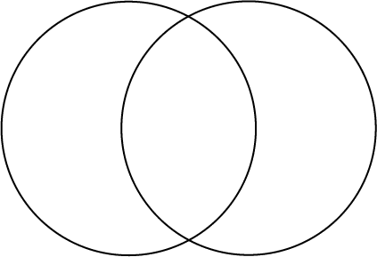
ME in Year 2
ME NOW
How I am
the same:
differences
differences

