Term 2: Week 1 Homework Project
Prodigy and Spellingcity must be done nightly.
1. Use the internet and books to find 10 facts about the animal that you chose in class.
- Please include the title of the source that you used (ie. name of book or name of website)
- Remember capitals at the beginning of your sentences, correct spelling, and punctuation at the end.
2. Draw an illustration of your animal

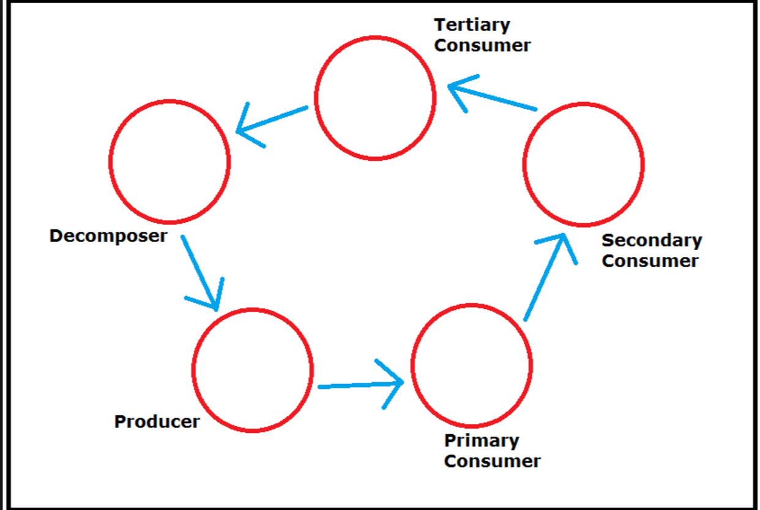
Term 2: Week 2 Homework Project
Prodigy and Spellingcity must be done nightly.
1. Research online or in books the habitat that your animal lives in. This should be the animal that you researched last week.
2. Colour in the map to show where we find your habitat on the planet.
3. Include 5 interesting facts about this habitat.
- What other animals or plants live in your habitat?
- How much rainfall is there each year?
- What is the climate in your habitat? (tropical, dry, moderate, continental, polar

Term 2: Week 3 Homework Project
Prodigy and Spellingcity must be done nightly.
1. Use the internet or books to research the food chain for your animal.
2. Use the diagram below to document the food chain for your animal.
Term 2: Week 4 Homework Project
Prodigy and Spellingcity must be done nightly.
1. Using books or the internet, research the life cycle of a tadpole.
2. Draw the tadpoles in different stages
3. Label the stages

Term 2: Week 5 Homework Project
Prodigy and Spellingcity must be done nightly.
1. Go back to your food chain from Week 3 and choose one element from your food chain.
2. Draw the life cycle of one element of your animal’s food chain.
- This could be another animal, a plant, or a decomposer found within your food chain.

Term 2: Week 6 Homework Project
Prodigy and Spellingcity must be done nightly.
- Research threats to your ecosystem using books or the internet.
(A threat is something that causes danger to your habitat. )
2. List one major threat and one minor threat to your ecosystem.
3. Describe what is causing your habitat to be in danger.

Term 2: Week 7 Homework Project
Prodigy and Spellingcity must be done nightly.
1. Describe the consequences caused by this threat.
2. What can humans do to help?

Term 2: Week 8 Homework Project
Prodigy and Spellingcity must be done nightly.
Complete any unfinished work on your diorama.
Please refer to the rubric in the UOI journal for more detailed information.

Term 2: Week 9 Homework Project
Prodigy and Spellingcity must be done nightly.

