Bahasa Indonesia Homework Yr 5 (Intermediate2-Ibu Denok) Term 4 Week 3-4
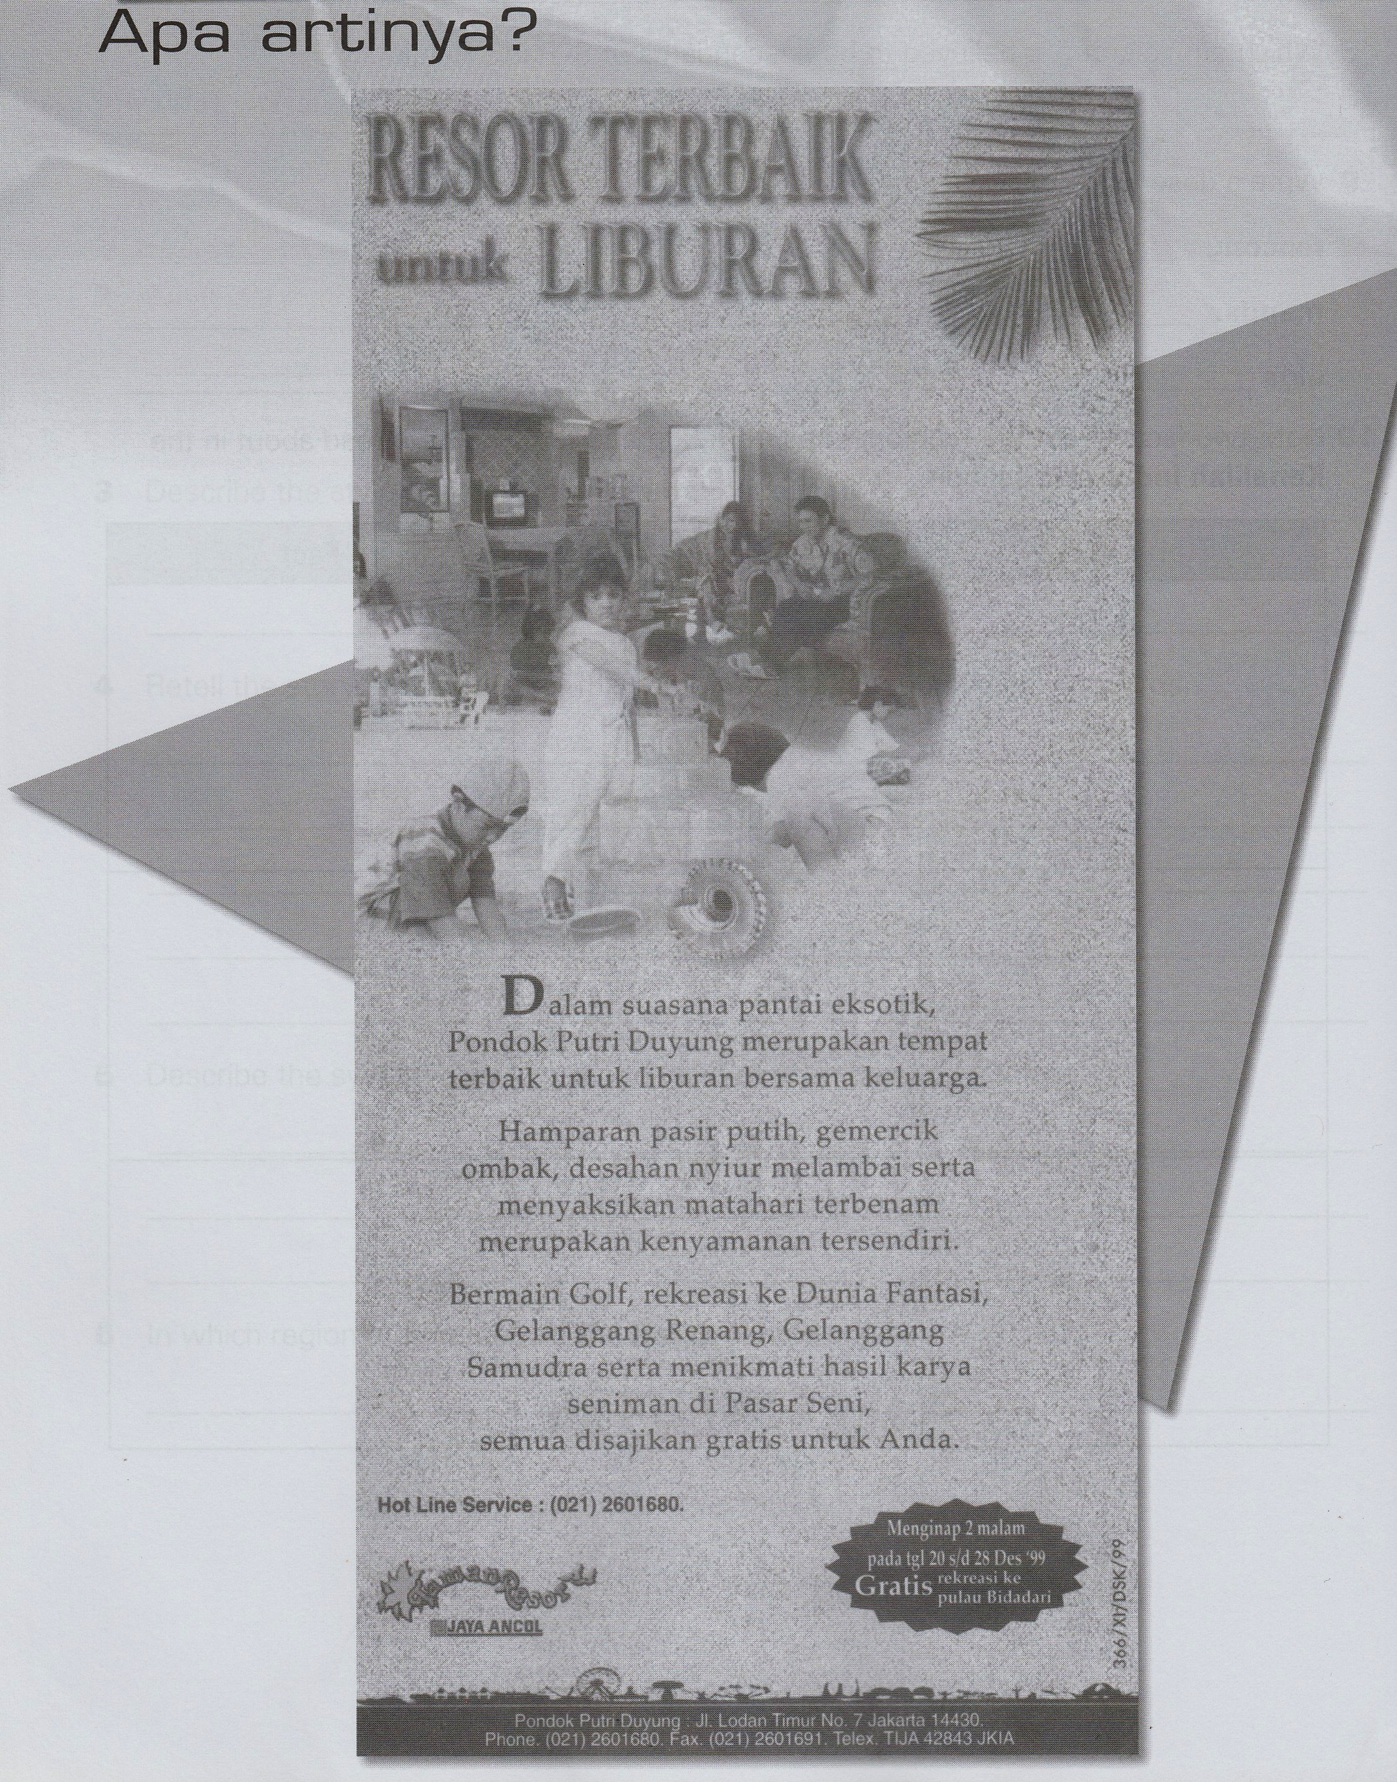
Due : Jumat, 05/Mei/2017
Read it and understand the meaning!

resor - resort
suasana – atmosphere
merupakan tempat terbaik – it is the best place
untuk - for
bersama- with
keluarga – family
hamparan – spread out area
pasir putih – white sand
gemercik –
ombak – wave
desahan nyiur melambai –

serta – also
menyaksikan – to see
matahari terbenam–sun set
kenyamanan – confortoble
rekreasi –
gelanggang -
samudra – ocean
menikmati – enjoy
hasil karya –
seniman – artist
disajikan – offered
gratis – free



